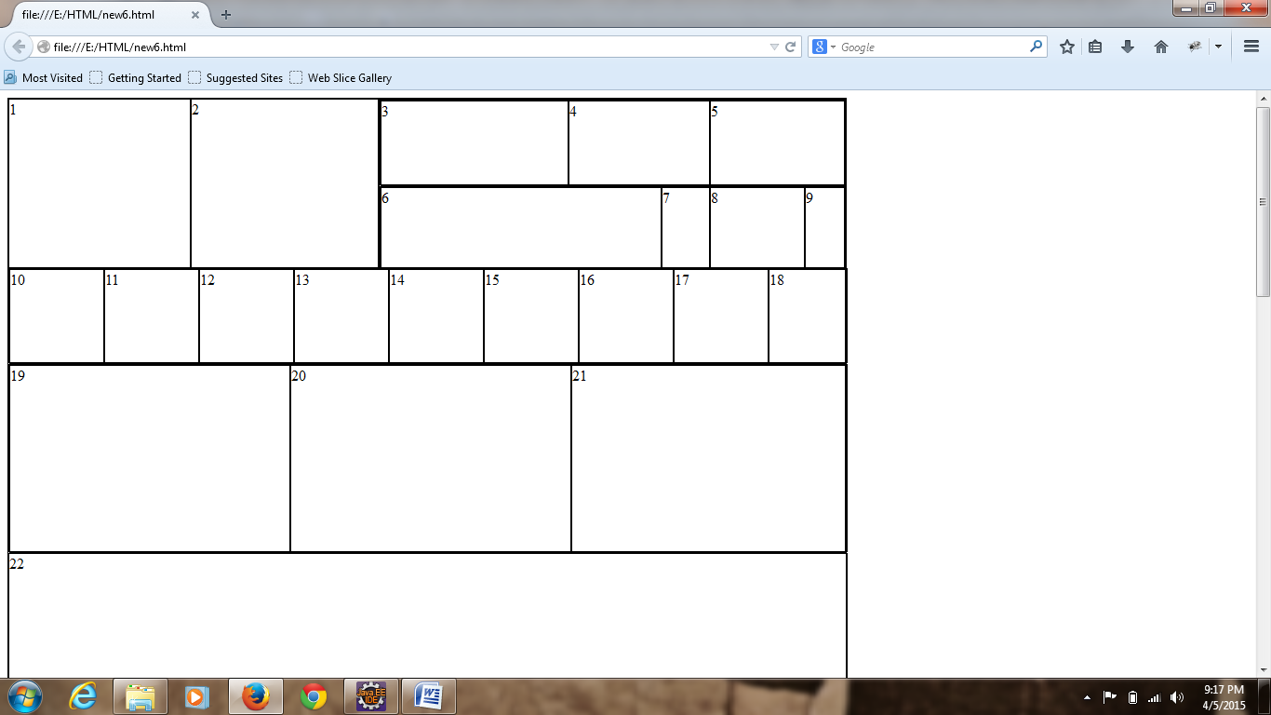

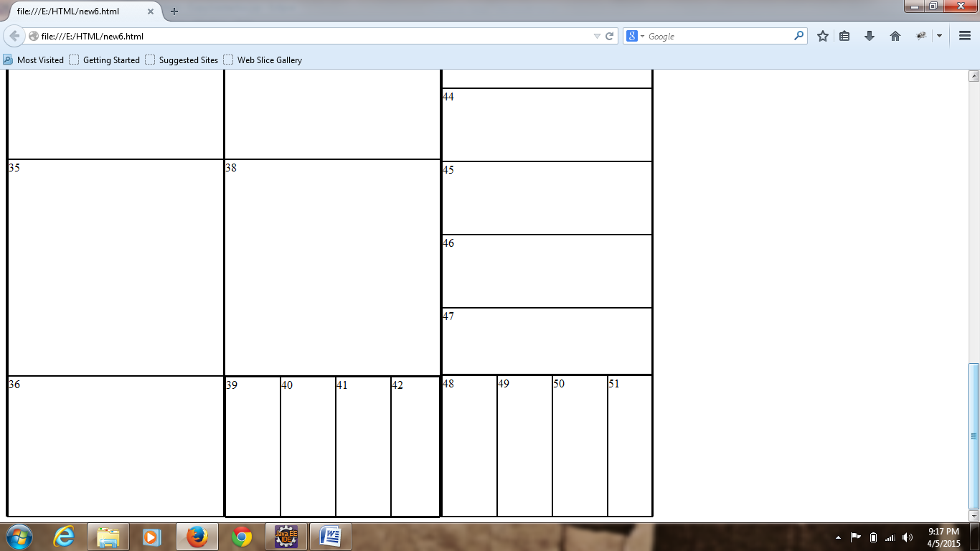

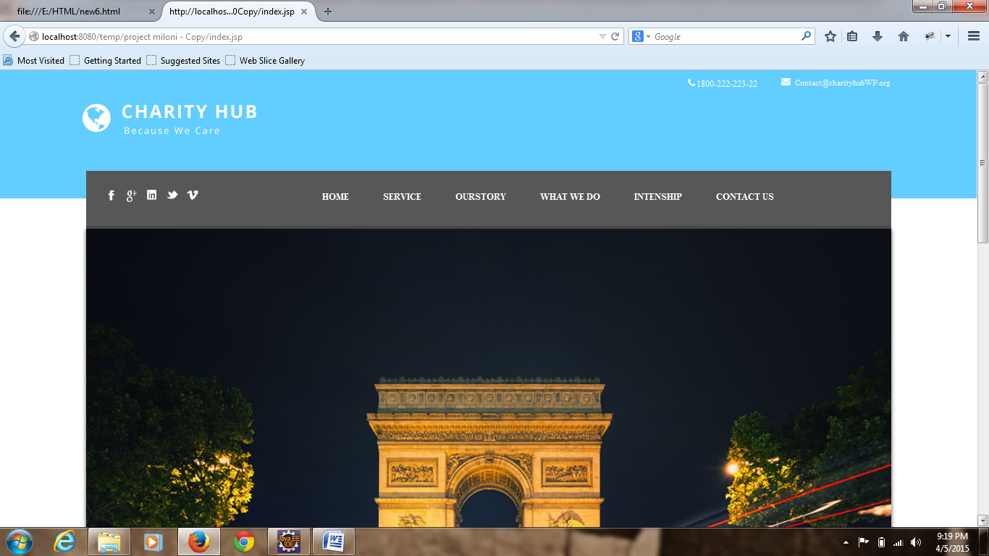

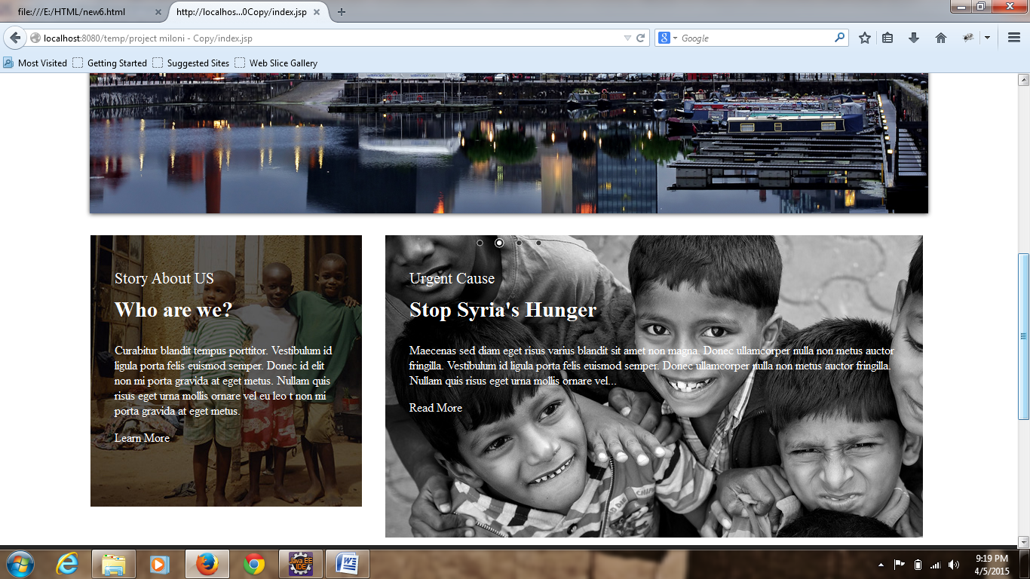

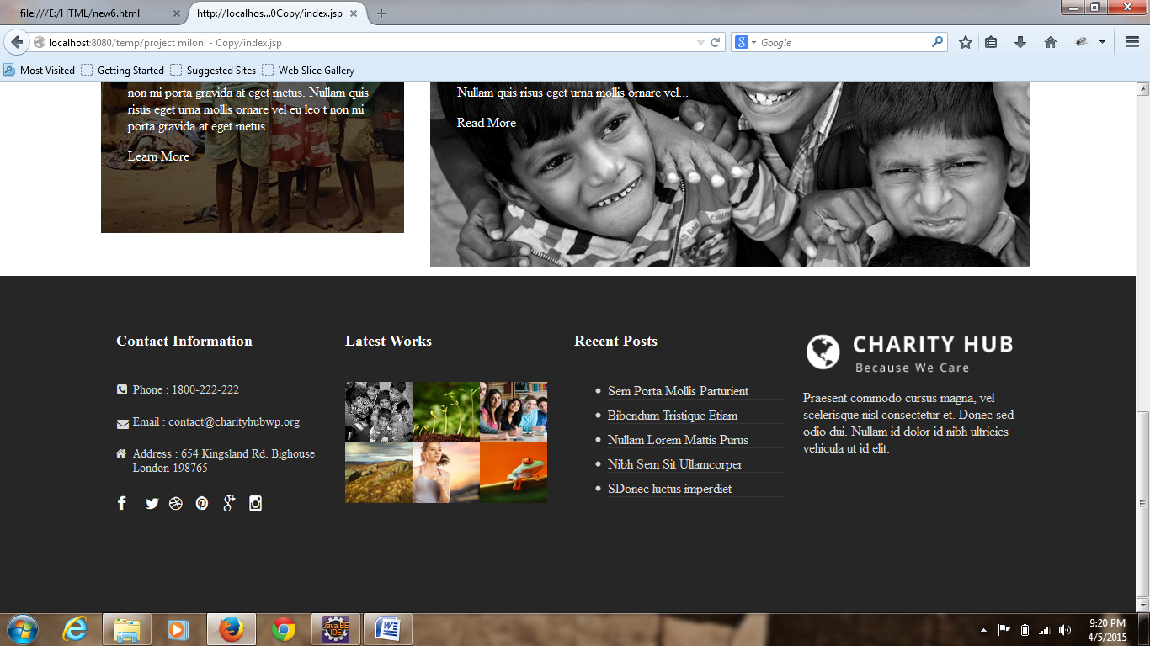

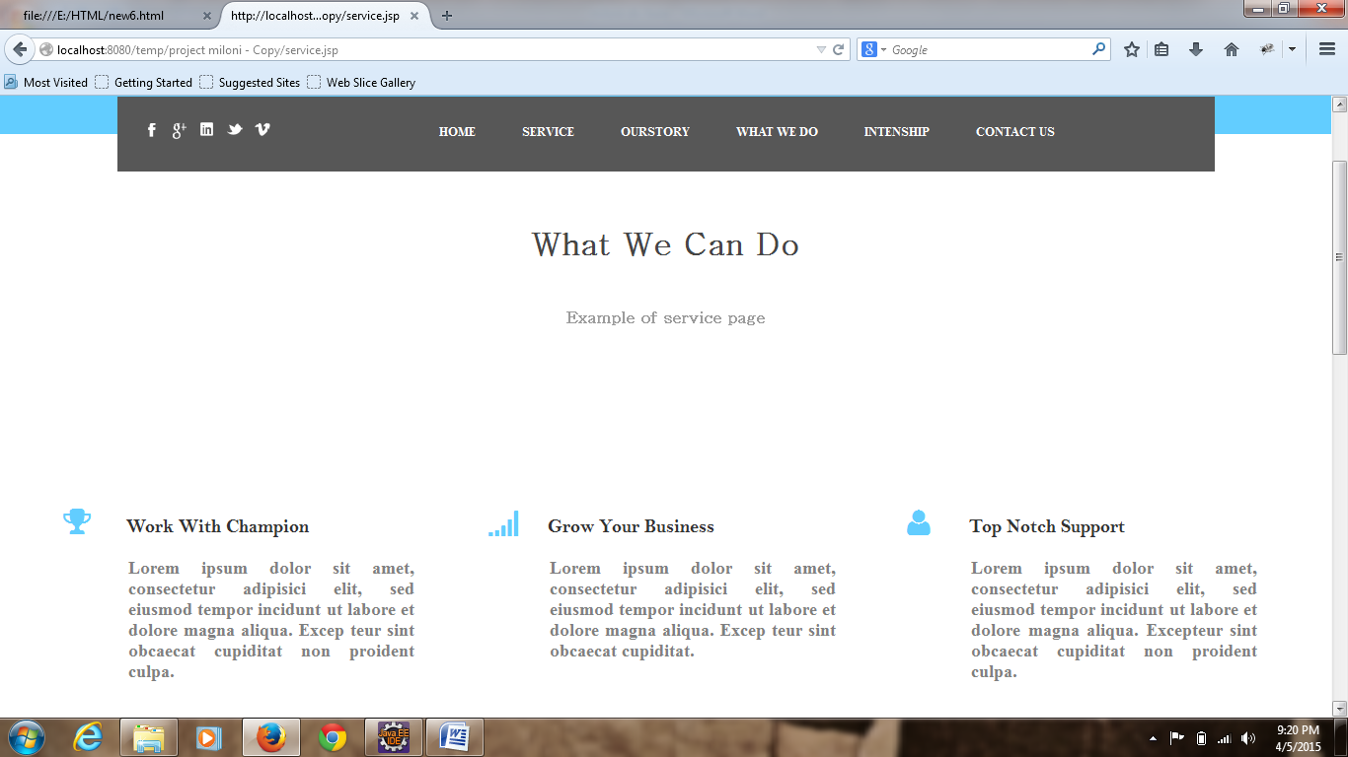

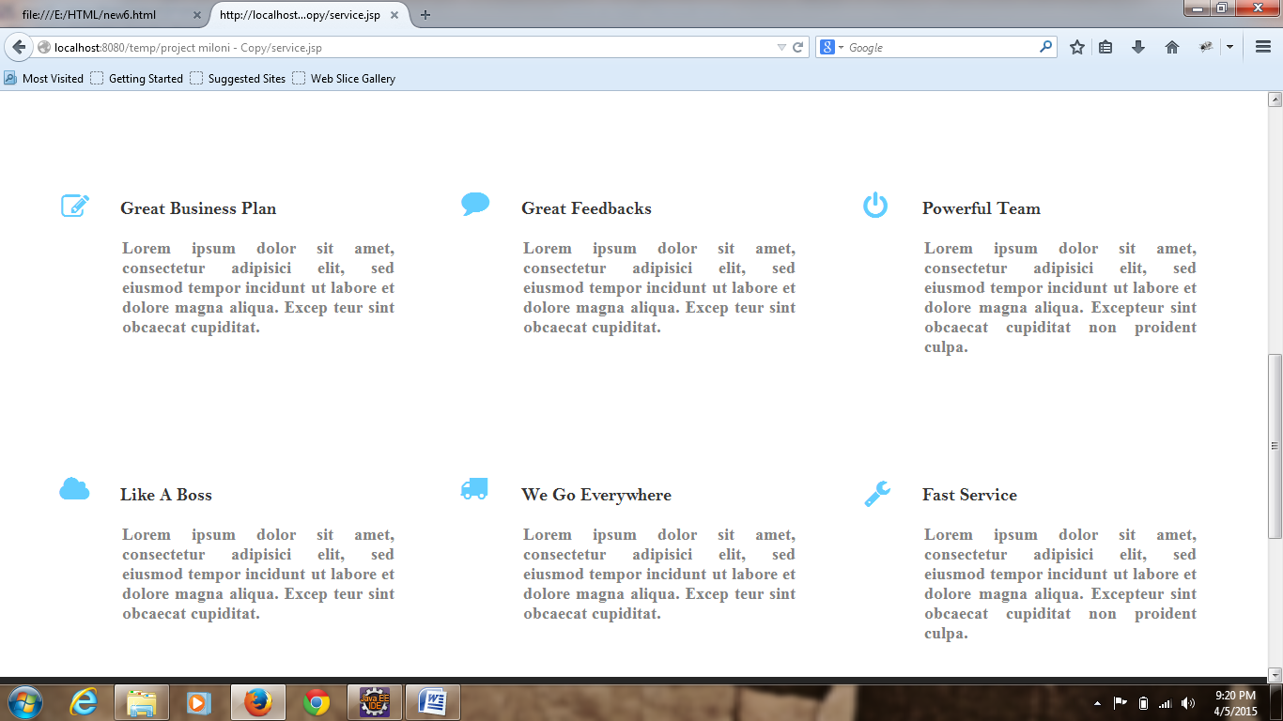

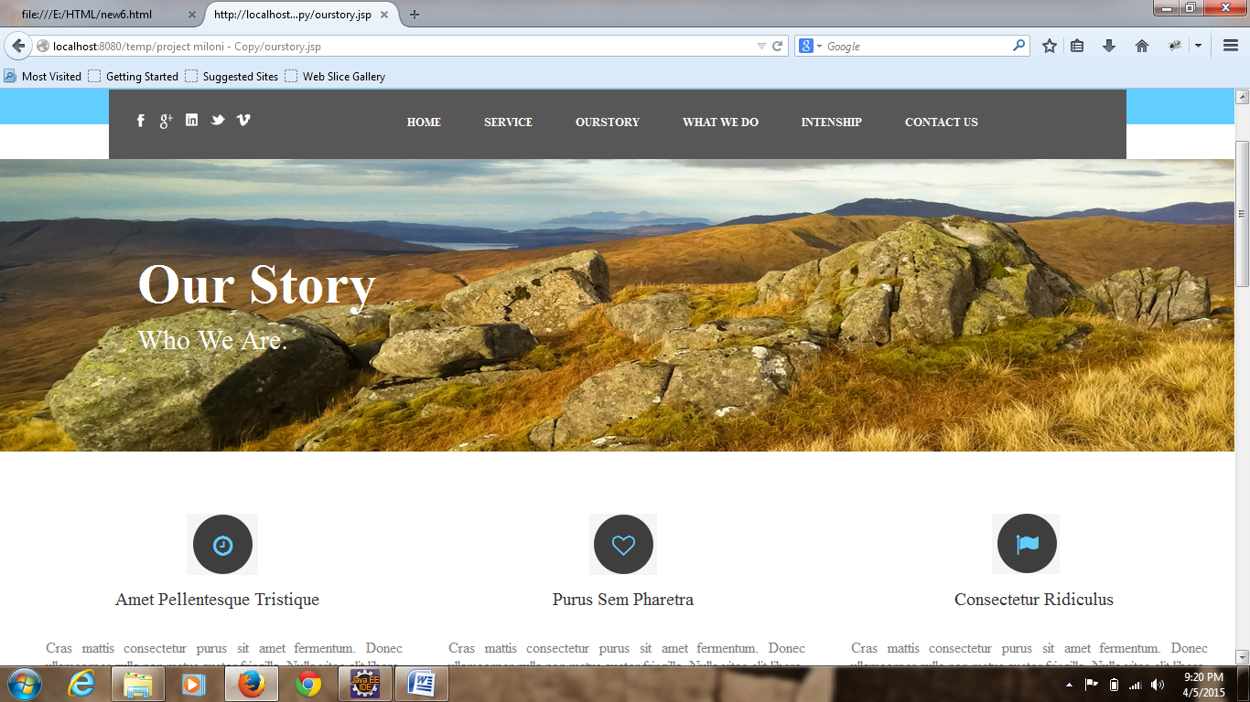

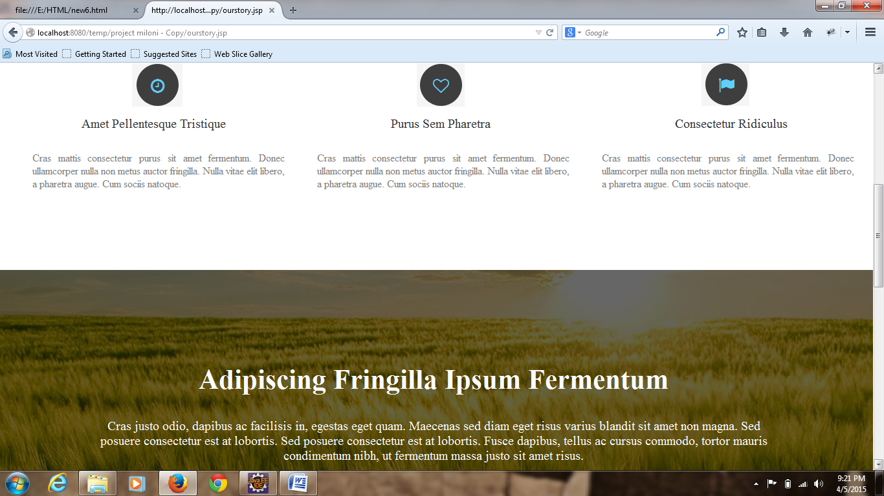

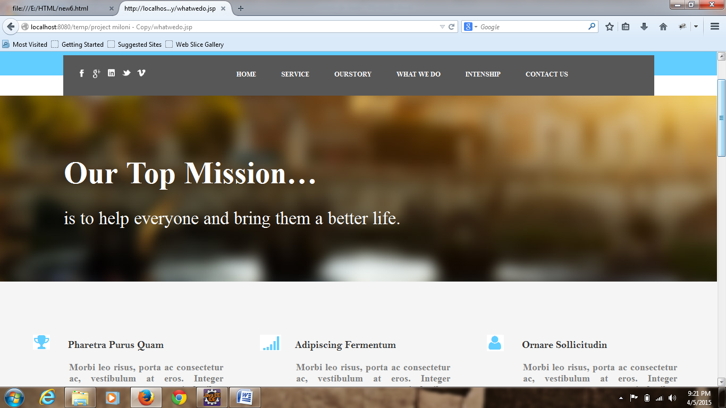

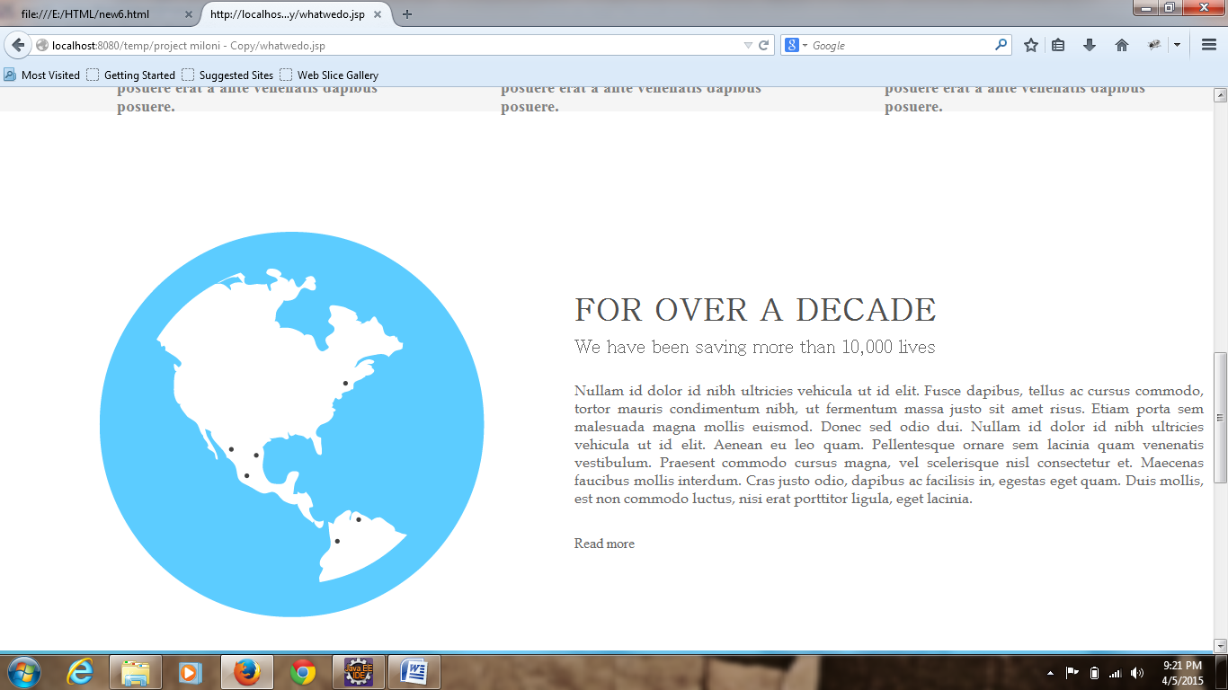

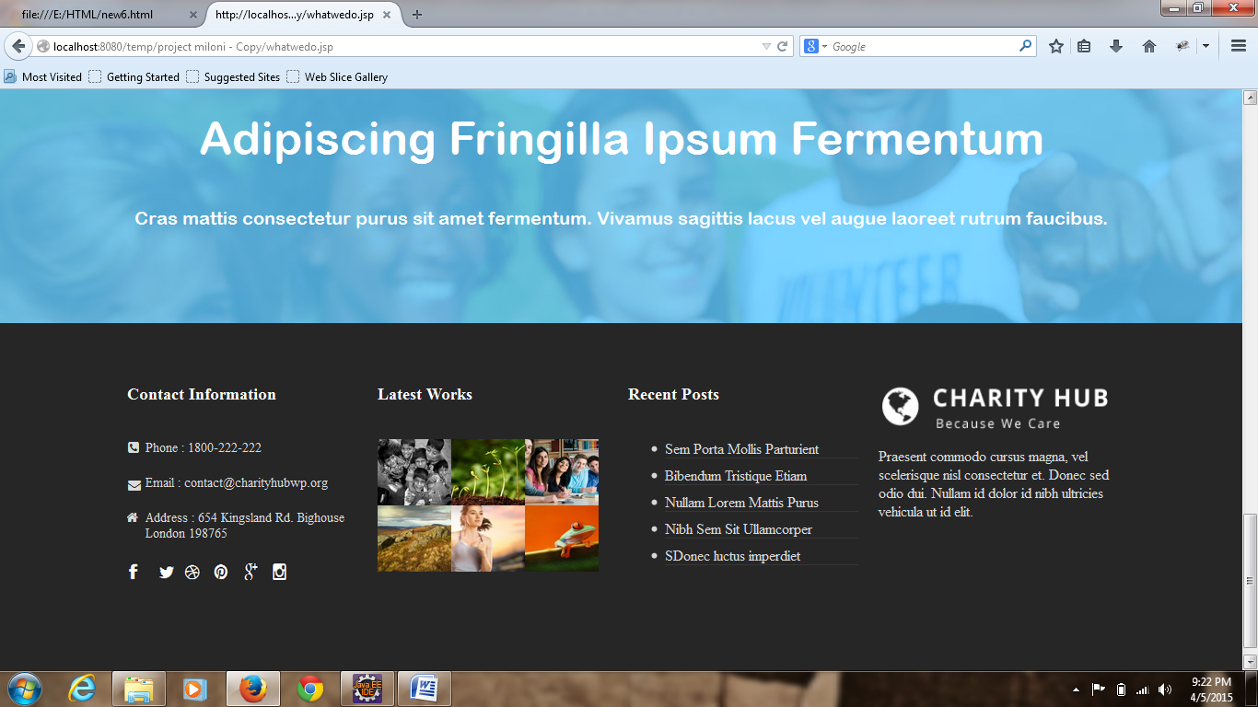

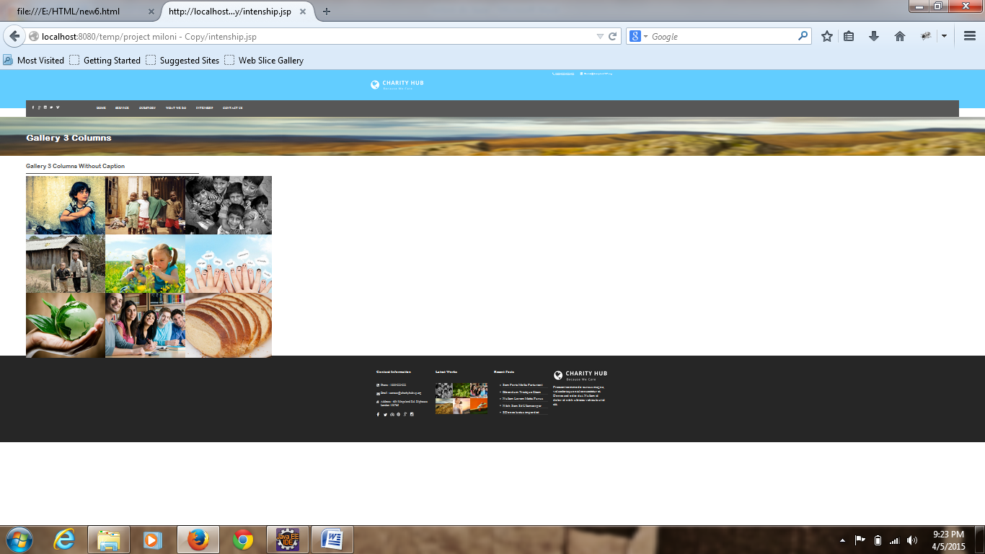

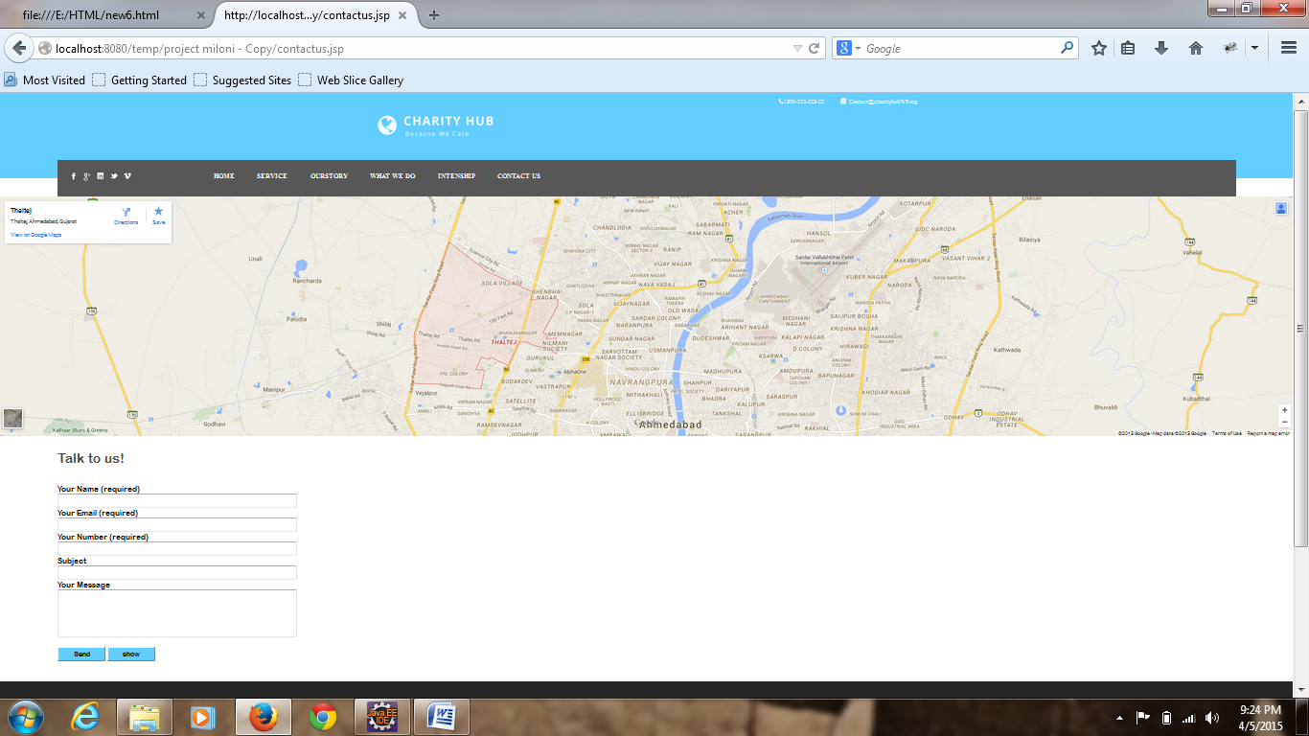

**Index.jsp**

<html>

<head>

<link href=*"style.css"* rel=*"stylesheet"*></link>

<link rel=*'stylesheet'* id=*'nivoslider-css'* href=*'css/nivo-slider.css?ver=4.0.1'* type=*'text/css'* media=*'all'* />

<!--<script type='text/javascript' src='js/jquery.js?ver=1.11.1'></script>-->

</head>

<body>

<div class=*"main"*>

<header>

<div class=*"header"*>

<div class=*"he"*>

<a href=*"#"*><div class=*"he1"*></div></a>

<div class=*"he2"*>

<div class=*"he3"*></div>

<div class=*"he4"*>1800-222-223-22</div>

<div class=*"he5"*>

<div class=*"he6"*></div>

<div class=*"he7"*>Contact@charityhubWP.org</div>

</div>

</div>

</div>

</div>

</header>

<div class=*"menu"*>

<div class=*"menu1"*>

<div class=*"mn"*></div>

<div class=*"mn1"*></div>

</div>

<div class=*"menu2"*>

<div class=*"men"*>

<a href=*"#"*><div class=*"men1"* style="background-repeat:*no-repeat*;background:*url('krunal/k1.png')*;"></div></a>

<a href=*"#"*><div class=*"men1"* style="background-repeat:*no-repeat*;background:*url('krunal/k2.png')*;"></div></a>

<a href=*"#"*><div class=*"men1"* style="background-repeat:*no-repeat*;background:*url('krunal/k3.png')*;"></div></a>

<a href=*"#"*><div class=*"men1"* style="background-repeat:*no-repeat*;background:*url('krunal/k4.png')*;"></div></a>

<a href=*"#"*><div class=*"men1"* style="background-repeat:*no-repeat*;background:*url('krunal/k5.png')*;"></div></a>

</div>

<nav class=*"men2"*>

<ul>

<li><a href=*"index.html"*><b>HOME</b></a></li>

<li><a href=*"service.html"*><b>SERVICE</b></a></li>

<li><a href=*"ourstory.html"*><b>OUTSTORY</b></a></li>

<li><a href=*"whatwedo.html"*><b>WHAT WE DO</b></a></li>

<li><a href=*"intenship.html"*><b>INTENSHIP</b></a></li>

<li><a href=*"contactus.html"*><b>CONTACT US</b></a></li>

<li><a href=*"#"*><b>LOGIN</b></a></li>

</ul>

</nav>

</div>

<div class=*"menu3"*>

<div class=*"mn"*></div>

<div class=*"mn1"*></div>

</div>

</div>

<div class=*"wrapper1"* style="clear:*left*">

<div id=*"page"* class=*"hfeed site"*>

<div class=*"slider-wrapper theme-default"*><div class=*"ribbon"*></div><div id=*"nivoslider-4"* class=*"nivoSlider"*><img src=*"img/5896103449_fa2c7a168d_b.jpg"* alt=*""* /><img src=*"img/03037_liverpool_1920x1080.jpg"* alt=*""* /><img src=*"img/3928848343_42443ae67d_o.jpg"* alt=*""* /><img src=*"img/4207529693_d4f03f6dd7_o.jpg"* alt=*""* /></div></div><script type=*"text/javascript"*>

jQuery(window).load(**function**(){

jQuery("#nivoslider-4").nivoSlider({

effect:"random",

slices:15,

boxCols:8,

boxRows:4,

animSpeed:500,

pauseTime:3000,

startSlide:0,

directionNav:**true**,

controlNav:**true**,

controlNavThumbs:**false**,

pauseOnHover:**true**,

manualAdvance:**false**

});

});

</script>

</div>

</div>

<div class=*"wrapper2"*>

<div class=*"wra"*>

<div class=*"im"*>Story About US</div>

<div class=*"im1"*><b>Who are we?</b></div>

<div class=*"im2"*>

<p>

Curabitur blandit tempus porttitor. Vestibulum id

ligula porta felis euismod semper. Donec id elit non

mi porta gravida at eget metus. Nullam quis risus

eget urna mollis ornare vel eu leo t non mi porta

gravida at eget metus.

</p>

<a href=*"our-story.html"* style="color:*white*;text-decoration:*none*;">Learn More</a>

</div>

</div>

<div class=*"wra1"*>

<div class=*"im"*>Urgent Cause</div>

<div class=*"im1"*><b>Stop Syria's Hunger</b></div>

<div class=*"wra2"*>

<p>

Maecenas sed diam eget risus varius blandit sit amet non

magna. Donec ullamcorper nulla non metus auctor fringilla.

Vestibulum id ligula porta felis euismod semper. Donec

ullamcorper nulla non metus auctor fringilla. Nullam quis

risus eget urna mollis ornare vel...

</p>

<a href=*"#"* style="color:*white*;text-decoration:*none*;">Read More</a>

</div>

</div>

</div>

<div class=*"footer"*>

<div class=*"footer-in"*>

<div class=*"footer1"*>

<div class=*"f1"*><b>Contact Information</b></div>

<div class=*"f2"*>

<div class=*"f3"*>

<div class=*"f4"*></div>

<div class=*"f5"*>Phone :

1800-222-222</div>

</div>

<div class=*"f6"*>

<div class=*"f7"*></div>

<div class=*"f5"*>Email :

contact@charityhubwp.org</div>

</div>

<div class=*"f8"*>

<div class=*"f9"*></div>

<div class=*"f5"*>Address : 654

Kingsland Rd. Bighouse London 198765</div>

</div>

<div class=*"f10"*>

<div class=*"f11"*></div>

<div class=*"f12"*></div>

<div class=*"f13"*></div>

<div class=*"f14"*></div>

<div class=*"f15"*></div>

<div class=*"f16"*></div>

</div>

</div>

</div>

<div class=*"footer2"*>

<div class=*"f1"*><b>Latest Works</b></div>

<div class=*"f2"*>

<div class=*"f2-1"*></div>

<div class=*"f2-2"*></div>

<div class=*"f2-3"*></div>

<div class=*"f2-4"*></div>

<div class=*"f2-5"*></div>

<div class=*"f2-6"*></div>

</div>

</div>

<div class=*"footer3"*>

<div class=*"f1"*><b>Recent Posts</b></div>

<div class=*"f2"*>

<div class=*"clear"*>

<ul>

<li><a href=*"#"*>Sem

Porta Mollis Parturient</a></li>

<li><a href=*"#"*>Bibendum

Tristique Etiam</a></li>

<li><a href=*"#"*>Nullam

Lorem Mattis Purus</a></li>

<li><a href=*"#"*>Nibh

Sem Sit Ullamcorper</a></li>

<li><a href=*"#"*>SDonec

luctus imperdiet</a></li>

</ul>

</div>

</div>

</div>

<div class=*"footer4"*>

<div class=*"ft"*></div>

<div class=*"ft-1"*><p>Praesent commodo cursus magna, vel scelerisque nisl

consectetur et. Donec sed odio dui. Nullam id dolor id nibh

ultricies vehicula ut id elit.</p></div>

</div>

</div>

</div>

</div>

<script type=*'text/javascript'* src=*'js/jquery.nivo.slider.pack.js?ver=4.0.1'*></script>

<link rel=*'stylesheet'* id=*'nivoslider-theme-default-css'* href=*'css/default.css?ver=4.0.1'* type=*'text/css'* media=*'all'* />

</body>

</html>

**Service.jsp**

<html>

<head>

<link href=*"style.css"* rel=*"stylesheet"*></link>

<link href=*"style1.css"* rel=*"stylesheet"*></link>

</head>

<body>

<div class=*"main"*>

<header>

<div class=*"header"*>

<div class=*"he"*>

<a href=*"#"*><div class=*"he1"*></div></a>

<div class=*"he2"*>

<div class=*"he3"*></div>

<div class=*"he4"*>1800-222-223-22</div>

<div class=*"he5"*>

<div class=*"he6"*></div>

<div class=*"he7"*>Contact@charityhubWP.org</div>

</div>

</div>

</div>

</div>

</header>

<div class=*"menu"*>

<div class=*"menu1"*>

<div class=*"mn"*></div>

<div class=*"mn1"*></div>

</div>

<div class=*"menu2"*>

<div class=*"men"*>

<a href=*"#"*><div class=*"men1"* style="background-repeat:*no-repeat*;background:*url('krunal/k1.png')*;"></div></a>

<a href=*"#"*><div class=*"men1"* style="background-repeat:*no-repeat*;background:*url('krunal/k2.png')*;"></div></a>

<a href=*"#"*><div class=*"men1"* style="background-repeat:*no-repeat*;background:*url('krunal/k3.png')*;"></div></a>

<a href=*"#"*><div class=*"men1"* style="background-repeat:*no-repeat*;background:*url('krunal/k4.png')*;"></div></a>

<a href=*"#"*><div class=*"men1"* style="background-repeat:*no-repeat*;background:*url('krunal/k5.png')*;"></div></a>

</div>

<nav class=*"men2"*>

<ul>

<li><a href=*"index.html"*><b>HOME</b></a></li>

<li><a href=*"service.html"*><b>SERVICE</b></a></li>

<li><a href=*"ourstory.html"*><b>OUTSTORY</b></a></li>

<li><a href=*"whatwedo.html"*><b>WHAT WE DO</b></a></li>

<li><a href=*"intenship.html"*><b>INTENSHIP</b></a></li>

<li><a href=*"contactus.html"*><b>CONTACT US</b></a></li>

<li><a href=*"#"*><b>LOGIN</b></a></li>

</ul>

</nav>

</div>

<div class=*"menu3"*>

<div class=*"mn"*></div>

<div class=*"mn1"*></div>

</div>

</div>

<div class=*"menu-in"*>

<div class=*"menu-in-1"*><h1 style="color:*#454545*;font-family:*Batang*">What We Can Do</h1></div>

<div class=*"menu-in-2"*><h4 style="color:*#9b9b9b*;font-family:*Batang*">Example of service page</h4></div>

</div>

<div class=*"wrapp"*>

<div class=*"wrapp1"*>

<div class=*"wrapp1-in"*></div>

<div class=*"wrapp1-in-1"*><h3 style="color:*#333333*;line-height:*0px*;font-family:*Bell MT*">Work With Champion</h3></div>

<div class=*"wrapp1-in-2"*><h1 style="text-align:*justify*;color:*gray*;font-size:*18px*;">Lorem ipsum dolor sit amet, consectetur adipisici elit, sed eiusmod tempor incidunt ut labore et dolore magna aliqua. Excep teur sint obcaecat cupiditat non proident culpa.</h1></div>

</div>

<div class=*"wrapp1"*>

<div class=*"wrapp1-in1"*></div>

<div class=*"wrapp1-in-1"*><h3 style="color:*#333333*;line-height:*0px*;font-family:*Bell MT*">Grow Your Business</h3></div>

<div class=*"wrapp1-in-2"*><h1 style="text-align:*justify*;color:*gray*;font-size:*18px*;">Lorem ipsum dolor sit amet, consectetur adipisici elit, sed eiusmod tempor incidunt ut labore et dolore magna aliqua. Excep teur sint obcaecat cupiditat.</h1></div>

</div>

<div class=*"wrapp1"*>

<div class=*"wrapp1-in2"*></div>

<div class=*"wrapp1-in-1"*><h3 style="color:*#333333*;line-height:*0px*;font-family:*Bell MT*">Top Notch Support</h3></div>

<div class=*"wrapp1-in-2"*><h1 style="text-align:*justify*;color:*gray*;font-size:*18px*;">Lorem ipsum dolor sit amet, consectetur adipisici elit, sed eiusmod tempor incidunt ut labore et dolore magna aliqua. Excepteur sint obcaecat cupiditat non proident culpa.</h1></div>

</div>

<div class=*"wrapp1"* style="clear:*both*">

<div class=*"wrapp1-in3"*></div>

<div class=*"wrapp1-in-1"*><h3 style="color:*#333333*;line-height:*0px*;font-family:*Bell MT*">Great Business Plan</h3></div>

<div class=*"wrapp1-in-2"*><h1 style="text-align:*justify*;color:*gray*;font-size:*18px*;">Lorem ipsum dolor sit amet, consectetur adipisici elit, sed eiusmod tempor incidunt ut labore et dolore magna aliqua. Excep teur sint obcaecat cupiditat.</h1></div>

</div>

<div class=*"wrapp1"*>

<div class=*"wrapp1-in4"*></div>

<div class=*"wrapp1-in-1"*><h3 style="color:*#333333*;line-height:*0px*;font-family:*Bell MT*">Great Feedbacks</h3></div>

<div class=*"wrapp1-in-2"*><h1 style="text-align:*justify*;color:*gray*;font-size:*18px*;">Lorem ipsum dolor sit amet, consectetur adipisici elit, sed eiusmod tempor incidunt ut labore et dolore magna aliqua. Excep teur sint obcaecat cupiditat.</h1></div>

</div>

<div class=*"wrapp1"*>

<div class=*"wrapp1-in5"*></div>

<div class=*"wrapp1-in-1"*><h3 style="color:*#333333*;line-height:*0px*;font-family:*Bell MT*">Powerful Team</h3></div>

<div class=*"wrapp1-in-2"*><h1 style="text-align:*justify*;color:*gray*;font-size:*18px*;">Lorem ipsum dolor sit amet, consectetur adipisici elit, sed eiusmod tempor incidunt ut labore et dolore magna aliqua. Excepteur sint obcaecat cupiditat non proident culpa.</h1></div>

</div>

<div class=*"wrapp1"* style="clear:*both*">

<div class=*"wrapp1-in6"*></div>

<div class=*"wrapp1-in-1"*><h3 style="color:*#333333*;line-height:*0px*;font-family:*Bell MT*">Like A Boss</h3></div>

<div class=*"wrapp1-in-2"*><h1 style="text-align:*justify*;color:*gray*;font-size:*18px*;">Lorem ipsum dolor sit amet, consectetur adipisici elit, sed eiusmod tempor incidunt ut labore et dolore magna aliqua. Excep teur sint obcaecat cupiditat.</h1></div>

</div>

<div class=*"wrapp1"*>

<div class=*"wrapp1-in7"*></div>

<div class=*"wrapp1-in-1"*><h3 style="color:*#333333*;line-height:*0px*;font-family:*Bell MT*">We Go Everywhere</h3></div>

<div class=*"wrapp1-in-2"*><h1 style="text-align:*justify*;color:*gray*;font-size:*18px*;">Lorem ipsum dolor sit amet, consectetur adipisici elit, sed eiusmod tempor incidunt ut labore et dolore magna aliqua. Excep teur sint obcaecat cupiditat.</h1></div>

</div>

<div class=*"wrapp1"*>

<div class=*"wrapp1-in8"*></div>

<div class=*"wrapp1-in-1"*><h3 style="color:*#333333*;line-height:*0px*;font-family:*Bell MT*">Fast Service</h3></div>

<div class=*"wrapp1-in-2"*><h1 style="text-align:*justify*;color:*gray*;font-size:*18px*;">Lorem ipsum dolor sit amet, consectetur adipisici elit, sed eiusmod tempor incidunt ut labore et dolore magna aliqua. Excepteur sint obcaecat cupiditat non proident culpa.</h1></div>

</div>

</div>

<div class=*"footer"*>

<div class=*"footer-in"*>

<div class=*"footer1"*>

<div class=*"f1"*><b>Contact Information</b></div>

<div class=*"f2"*>

<div class=*"f3"*>

<div class=*"f4"*></div>

<div class=*"f5"*>Phone :

1800-222-222</div>

</div>

<div class=*"f6"*>

<div class=*"f7"*></div>

<div class=*"f5"*>Email :

contact@charityhubwp.org</div>

</div>

<div class=*"f8"*>

<div class=*"f9"*></div>

<div class=*"f5"*>Address : 654

Kingsland Rd. Bighouse London 198765</div>

</div>

<div class=*"f10"*>

<div class=*"f11"*></div>

<div class=*"f12"*></div>

<div class=*"f13"*></div>

<div class=*"f14"*></div>

<div class=*"f15"*></div>

<div class=*"f16"*></div>

</div>

</div>

</div>

<div class=*"footer2"*>

<div class=*"f1"*><b>Latest Works</b></div>

<div class=*"f2"*>

<div class=*"f2-1"*></div>

<div class=*"f2-2"*></div>

<div class=*"f2-3"*></div>

<div class=*"f2-4"*></div>

<div class=*"f2-5"*></div>

<div class=*"f2-6"*></div>

</div>

</div>

<div class=*"footer3"*>

<div class=*"f1"*><b>Recent Posts</b></div>

<div class=*"f2"*>

<div class=*"clear"*>

<ul>

<li><a href=*"#"*>Sem

Porta Mollis Parturient</a></li>

<li><a href=*"#"*>Bibendum

Tristique Etiam</a></li>

<li><a href=*"#"*>Nullam

Lorem Mattis Purus</a></li>

<li><a href=*"#"*>Nibh

Sem Sit Ullamcorper</a></li>

<li><a href=*"#"*>SDonec

luctus imperdiet</a></li>

</ul>

</div>

</div>

</div>

<div class=*"footer4"*>

<div class=*"ft"*></div>

<div class=*"ft-1"*><p>Praesent commodo cursus magna, vel scelerisque nisl

consectetur et. Donec sed odio dui. Nullam id dolor id nibh

ultricies vehicula ut id elit.</p></div>

</div>

</div>

</div>

</div>

**Whatwedo.jsp**

<html>

<head>

<link href=*"style.css"* rel=*"stylesheet"*></link>

<link href=*"style3.css"* rel=*"stylesheet"*></link>

<link href=*"style1.css"* rel=*"stylesheet"*></link>

</head>

<body>

<div class=*"main"*>

<header>

<div class=*"header"*>

<div class=*"he"*>

<a href=*"#"*><div class=*"he1"*></div></a>

<div class=*"he2"*>

<div class=*"he3"*></div>

<div class=*"he4"*>1800-222-223-22</div>

<div class=*"he5"*>

<div class=*"he6"*></div>

<div class=*"he7"*>Contact@charityhubWP.org</div>

</div>

</div>

</div>

</div>

</header>

<div class=*"menu"*>

<div class=*"menu1"*>

<div class=*"mn"*></div>

<div class=*"mn1"*></div>

</div>

<div class=*"menu2"*>

<div class=*"men"*>

<a href=*"#"*><div class=*"men1"* style="background-repeat:*no-repeat*;background:*url('krunal/k1.png')*;"></div></a>

<a href=*"#"*><div class=*"men1"* style="background-repeat:*no-repeat*;background:*url('krunal/k2.png')*;"></div></a>

<a href=*"#"*><div class=*"men1"* style="background-repeat:*no-repeat*;background:*url('krunal/k3.png')*;"></div></a>

<a href=*"#"*><div class=*"men1"* style="background-repeat:*no-repeat*;background:*url('krunal/k4.png')*;"></div></a>

<a href=*"#"*><div class=*"men1"* style="background-repeat:*no-repeat*;background:*url('krunal/k5.png')*;"></div></a>

</div>

<nav class=*"men2"*>

<ul>

<li><a href=*"index.html"*><b>HOME</b></a></li>

<li><a href=*"service.html"*><b>SERVICE</b></a></li>

<li><a href=*"ourstory.html"*><b>OUTSTORY</b></a></li>

<li><a href=*"whatwedo.html"*><b>WHAT WE DO</b></a></li>

<li><a href=*"intenship.html"*><b>INTENSHIP</b></a></li>

<li><a href=*"contactus.html"*><b>CONTACT US</b></a></li>

<li><a href=*"#"*><b>LOGIN</b></a></li>

</ul>

</nav>

</div>

<div class=*"menu3"*>

<div class=*"mn"*></div>

<div class=*"mn1"*></div>

</div>

</div>

<div class=*"what-1"*>

<div class=*"what-2"*><b>Our Top Mission…</b></div>

<div class=*"what-3"*>is to help everyone and bring them a better life.</div>

</div>

<div class=*"wrapp0"*>

<div class=*"wrapp1"*>

<div class=*"wrapp1-in"*></div>

<div class=*"wrapp1-in-1"*><h3 style="color:*#333333*;line-height:*0px*;font-family:*Bell MT*;">Pharetra Purus Quam</h3></div>

<div class=*"wrapp1-in-2"*><h1 style="text-align:*justify*;color:*gray*;font-size:*18px*;">Morbi leo risus, porta ac consectetur ac, vestibulum at eros. Integer posuere erat a ante venenatis dapibus posuere.</h1></div>

</div>

<div class=*"wrapp1"*>

<div class=*"wrapp1-in1"*></div>

<div class=*"wrapp1-in-1"*><h3 style="color:*#333333*;line-height:*0px*;font-family:*Bell MT*;">Adipiscing Fermentum</h3></div>

<div class=*"wrapp1-in-2"*><h1 style="text-align:*justify*;color:*gray*;font-size:*18px*;">Morbi leo risus, porta ac consectetur ac, vestibulum at eros. Integer posuere erat a ante venenatis dapibus posuere.</h1></div>

</div>

<div class=*"wrapp1"*>

<div class=*"wrapp1-in2"*></div>

<div class=*"wrapp1-in-1"*><h3 style="color:*#333333*;line-height:*0px*;font-family:*Bell MT*;">Ornare Sollicitudin</h3></div>

<div class=*"wrapp1-in-2"*><h1 style="text-align:*justify*;color:*gray*;font-size:*18px*;">Morbi leo risus, porta ac consectetur ac, vestibulum at eros. Integer posuere erat a ante venenatis dapibus posuere.</h1></div>

</div>

<div class=*"wrapp1"* style="clear:*both*">

<div class=*"wrapp1-in3"*></div>

<div class=*"wrapp1-in-1"*><h3 style="color:*#333333*;line-height:*0px*;font-family:*Bell MT*;">Ridiculus Ullamcorper</h3></div>

<div class=*"wrapp1-in-2"*><h1 style="text-align:*justify*;color:*gray*;font-size:*18px*;">Morbi leo risus, porta ac consectetur ac, vestibulum at eros. Integer posuere erat a ante venenatis dapibus posuere.</h1></div>

</div>

<div class=*"wrapp1"*>

<div class=*"wrapp1-in4"*></div>

<div class=*"wrapp1-in-1"*><h3 style="color:*#333333*;line-height:*0px*;font-family:*Bell MT*;">Ultricies Ullamcorper</h3></div>

<div class=*"wrapp1-in-2"*><h1 style="text-align:*justify*;color:*gray*;font-size:*18px*;">Morbi leo risus, porta ac consectetur ac, vestibulum at eros. Integer posuere erat a ante venenatis dapibus posuere.</h1></div>

</div>

<div class=*"wrapp1"*>

<div class=*"wrapp1-in5"*></div>

<div class=*"wrapp1-in-1"*><h3 style="color:*#333333*;line-height:*0px*;font-family:*Bell MT*;">Lorem Condimentum</h3></div>

<div class=*"wrapp1-in-2"*><h1 style="text-align:*justify*;color:*gray*;font-size:*18px*;">Morbi leo risus, porta ac consectetur ac, vestibulum at eros. Integer posuere erat a ante venenatis dapibus posuere.</h1></div>

</div>

</div>

<div class=*"miloni"*>

<div class=*"miloni-1"*></div>

<div class=*"miloni-2"*>

<div class=*"miloni-3"*><b>FOR OVER A DECADE</b></div>

<div class=*"miloni-4"*>We have been saving more than 10,000 lives</div>

<div class=*"miloni-5"*>Nullam id dolor id nibh ultricies vehicula ut id elit. Fusce dapibus, tellus ac cursus commodo, tortor mauris condimentum nibh, ut fermentum massa justo sit amet risus. Etiam porta sem malesuada magna mollis euismod. Donec sed odio dui. Nullam id dolor id nibh ultricies vehicula ut id elit. Aenean eu leo quam. Pellentesque ornare sem lacinia quam venenatis vestibulum. Praesent commodo cursus magna, vel scelerisque nisl consectetur et. Maecenas faucibus mollis interdum. Cras justo odio, dapibus ac facilisis in, egestas eget quam. Duis mollis, est non commodo luctus, nisi erat porttitor ligula, eget lacinia.</div>

<div class=*"miloni-6"*><a href=*"#"* style="text-decoration:*none*;color:*#636363*;">Read more</a></div>

</div>

</div>

<div class=*"hetal"*>

<div class=*"hetal1"*>Adipiscing Fringilla Ipsum Fermentum</div>

<div class=*"hetal2"*>Cras mattis consectetur purus sit amet fermentum. Vivamus sagittis lacus vel augue laoreet rutrum faucibus.</div>

</div>

<div class=*"footer"*>

<div class=*"footer-in"*>

<div class=*"footer1"*>

<div class=*"f1"*><b>Contact Information</b></div>

<div class=*"f2"*>

<div class=*"f3"*>

<div class=*"f4"*></div>

<div class=*"f5"*>Phone :

1800-222-222</div>

</div>

<div class=*"f6"*>

<div class=*"f7"*></div>

<div class=*"f5"*>Email :

contact@charityhubwp.org</div>

</div>

<div class=*"f8"*>

<div class=*"f9"*></div>

<div class=*"f5"*>Address : 654

Kingsland Rd. Bighouse London 198765</div>

</div>

<div class=*"f10"*>

<div class=*"f11"*></div>

<div class=*"f12"*></div>

<div class=*"f13"*></div>

<div class=*"f14"*></div>

<div class=*"f15"*></div>

<div class=*"f16"*></div>

</div>

</div>

</div>

<div class=*"footer2"*>

<div class=*"f1"*><b>Latest Works</b></div>

<div class=*"f2"*>

<div class=*"f2-1"*></div>

<div class=*"f2-2"*></div>

<div class=*"f2-3"*></div>

<div class=*"f2-4"*></div>

<div class=*"f2-5"*></div>

<div class=*"f2-6"*></div>

</div>

</div>

<div class=*"footer3"*>

<div class=*"f1"*><b>Recent Posts</b></div>

<div class=*"f2"*>

<div class=*"clear"*>

<ul>

<li><a href=*"#"*>Sem

Porta Mollis Parturient</a></li>

<li><a href=*"#"*>Bibendum

Tristique Etiam</a></li>

<li><a href=*"#"*>Nullam

Lorem Mattis Purus</a></li>

<li><a href=*"#"*>Nibh

Sem Sit Ullamcorper</a></li>

<li><a href=*"#"*>SDonec

luctus imperdiet</a></li>

</ul>

</div>

</div>

</div>

<div class=*"footer4"*>

<div class=*"ft"*></div>

<div class=*"ft-1"*><p>Praesent commodo cursus magna, vel scelerisque nisl

consectetur et. Donec sed odio dui. Nullam id dolor id nibh

ultricies vehicula ut id elit.</p></div>

</div>

</div>

</div>

</div>

</html>

**Contactus.jsp**

<html>

<head>

<link href=*"style.css"* rel=*"stylesheet"*></link>

<link href=*"style5.css"* rel=*"stylesheet"*></link>

</head>

<body>

<div class=*"main"*>

<header>

<div class=*"header"*>

<div class=*"he"*>

<a href=*"#"*><div class=*"he1"*></div></a>

<div class=*"he2"*>

<div class=*"he3"*></div>

<div class=*"he4"*>1800-222-223-22</div>

<div class=*"he5"*>

<div class=*"he6"*></div>

<div class=*"he7"*>Contact@charityhubWP.org</div>

</div>

</div>

</div>

</div>

</header>

<div class=*"menu"*>

<div class=*"menu1"*>

<div class=*"mn"*></div>

<div class=*"mn1"*></div>

</div>

<div class=*"menu2"*>

<div class=*"men"*>

<a href=*"#"*><div class=*"men1"* style="background-repeat:*no-repeat*;background:*url('krunal/k1.png')*;"></div></a>

<a href=*"#"*><div class=*"men1"* style="background-repeat:*no-repeat*;background:*url('krunal/k2.png')*;"></div></a>

<a href=*"#"*><div class=*"men1"* style="background-repeat:*no-repeat*;background:*url('krunal/k3.png')*;"></div></a>

<a href=*"#"*><div class=*"men1"* style="background-repeat:*no-repeat*;background:*url('krunal/k4.png')*;"></div></a>

<a href=*"#"*><div class=*"men1"* style="background-repeat:*no-repeat*;background:*url('krunal/k5.png')*;"></div></a>

</div>

<nav class=*"men2"*>

<ul>

<li><a href=*"index.html"*><b>HOME</b></a></li>

<li><a href=*"service.html"*><b>SERVICE</b></a></li>

<li><a href=*"ourstory.html"*><b>OUTSTORY</b></a></li>

<li><a href=*"whatwedo.html"*><b>WHAT WE DO</b></a></li>

<li><a href=*"intenship.html"*><b>INTENSHIP</b></a></li>

<li><a href=*"contactus.html"*><b>CONTACT US</b></a></li>

<li><a href=*"#"*><b>LOGIN</b></a></li>

</ul>

</nav>

</div>

<div class=*"menu3"*>

<div class=*"mn"*></div>

<div class=*"mn1"*></div>

</div>

</div>

<div class=*"contact"*><iframe src=*"https://www.google.com/maps/embed?pb=!1m18!1m12!1m3!1d29368.433138064695!2d72.50512314999999!3d23.058476550000012!2m3!1f0!2f0!3f0!3m2!1i1024!2i768!4f13.1!3m3!1m2!1s0x395e9ca1402b2107%3A0xc6b7cfd374cb4bcb!2sThaltej%2C+Ahmedabad%2C+Gujarat!5e0!3m2!1sen!2sin!4v1424883996575"* width=*"100%"* height=*"500"* frameborder=*"0"* style="border:*0*"></iframe></div>

<div class=*"contact1"*>

<div class=*"contact2"*>Talk to us!</div>

<form action=*"#"* method=*"post"*>

<div class=*"contact3"*>Your Name (required)</div>

<div class=*"contact4"*>

<input type=*"text"* name=*""* value=*""* id=*""* style="height:*30px*;width:*500px*;">

</div>

<div class=*"contact3"*>Your Email (required)</div>

<div class=*"contact4"*>

<input type=*"email"* name=*""* value=*""* id=*""* style="height:*30px*;width:*500px*;">

</div>

<div class=*"contact3"*>Your Number (required)</div>

<div class=*"contact4"*>

<input type=*"text"* name=*""* value=*""* id=*""* style="height:*30px*;width:*500px*;">

</div>

<div class=*"contact3"*>Subject</div>

<div class=*"contact4"*>

<input type=*"text"* name=*""* value=*""* id=*""* style="height:*30px*;width:*500px*;">

</div>

<div class=*"contact3"*>Your Message</div>

<div class=*"contact4"*>

<input type=*"text"* name=*""* value=*""* id=*""* style="height:*100px*;width:*500px*;">

</div>

<div class=*"contact3"*></div>

<div class=*"contact4"*>

<input type=*"button"* name=*""* value=*"Send"* id=*""* style="height:*30px*;width:*100px*;background-color:*#62cdff*;font-family:*Arial Rounded MT Bold*;">

</div>

</form>

</div>

<div class=*"footer"*>

<div class=*"footer-in"*>

<div class=*"footer1"*>

<div class=*"f1"*><b>Contact Information</b></div>

<div class=*"f2"*>

<div class=*"f3"*>

<div class=*"f4"*></div>

<div class=*"f5"*>Phone :

1800-222-222</div>

</div>

<div class=*"f6"*>

<div class=*"f7"*></div>

<div class=*"f5"*>Email :

contact@charityhubwp.org</div>

</div>

<div class=*"f8"*>

<div class=*"f9"*></div>

<div class=*"f5"*>Address : 654

Kingsland Rd. Bighouse London 198765</div>

</div>

<div class=*"f10"*>

<div class=*"f11"*></div>

<div class=*"f12"*></div>

<div class=*"f13"*></div>

<div class=*"f14"*></div>

<div class=*"f15"*></div>

<div class=*"f16"*></div>

</div>

</div>

</div>

<div class=*"footer2"*>

<div class=*"f1"*><b>Latest Works</b></div>

<div class=*"f2"*>

<div class=*"f2-1"*></div>

<div class=*"f2-2"*></div>

<div class=*"f2-3"*></div>

<div class=*"f2-4"*></div>

<div class=*"f2-5"*></div>

<div class=*"f2-6"*></div>

</div>

</div>

<div class=*"footer3"*>

<div class=*"f1"*><b>Recent Posts</b></div>

<div class=*"f2"*>

<div class=*"clear"*>

<ul>

<li><a href=*"#"*>Sem

Porta Mollis Parturient</a></li>

<li><a href=*"#"*>Bibendum

Tristique Etiam</a></li>

<li><a href=*"#"*>Nullam

Lorem Mattis Purus</a></li>

<li><a href=*"#"*>Nibh

Sem Sit Ullamcorper</a></li>

<li><a href=*"#"*>SDonec

luctus imperdiet</a></li>

</ul>

</div>

</div>

</div>

<div class=*"footer4"*>

<div class=*"ft"*></div>

<div class=*"ft-1"*><p>Praesent commodo cursus magna, vel scelerisque nisl

consectetur et. Donec sed odio dui. Nullam id dolor id nibh

ultricies vehicula ut id elit.</p></div>

</div>

</div>

</div>

</html>